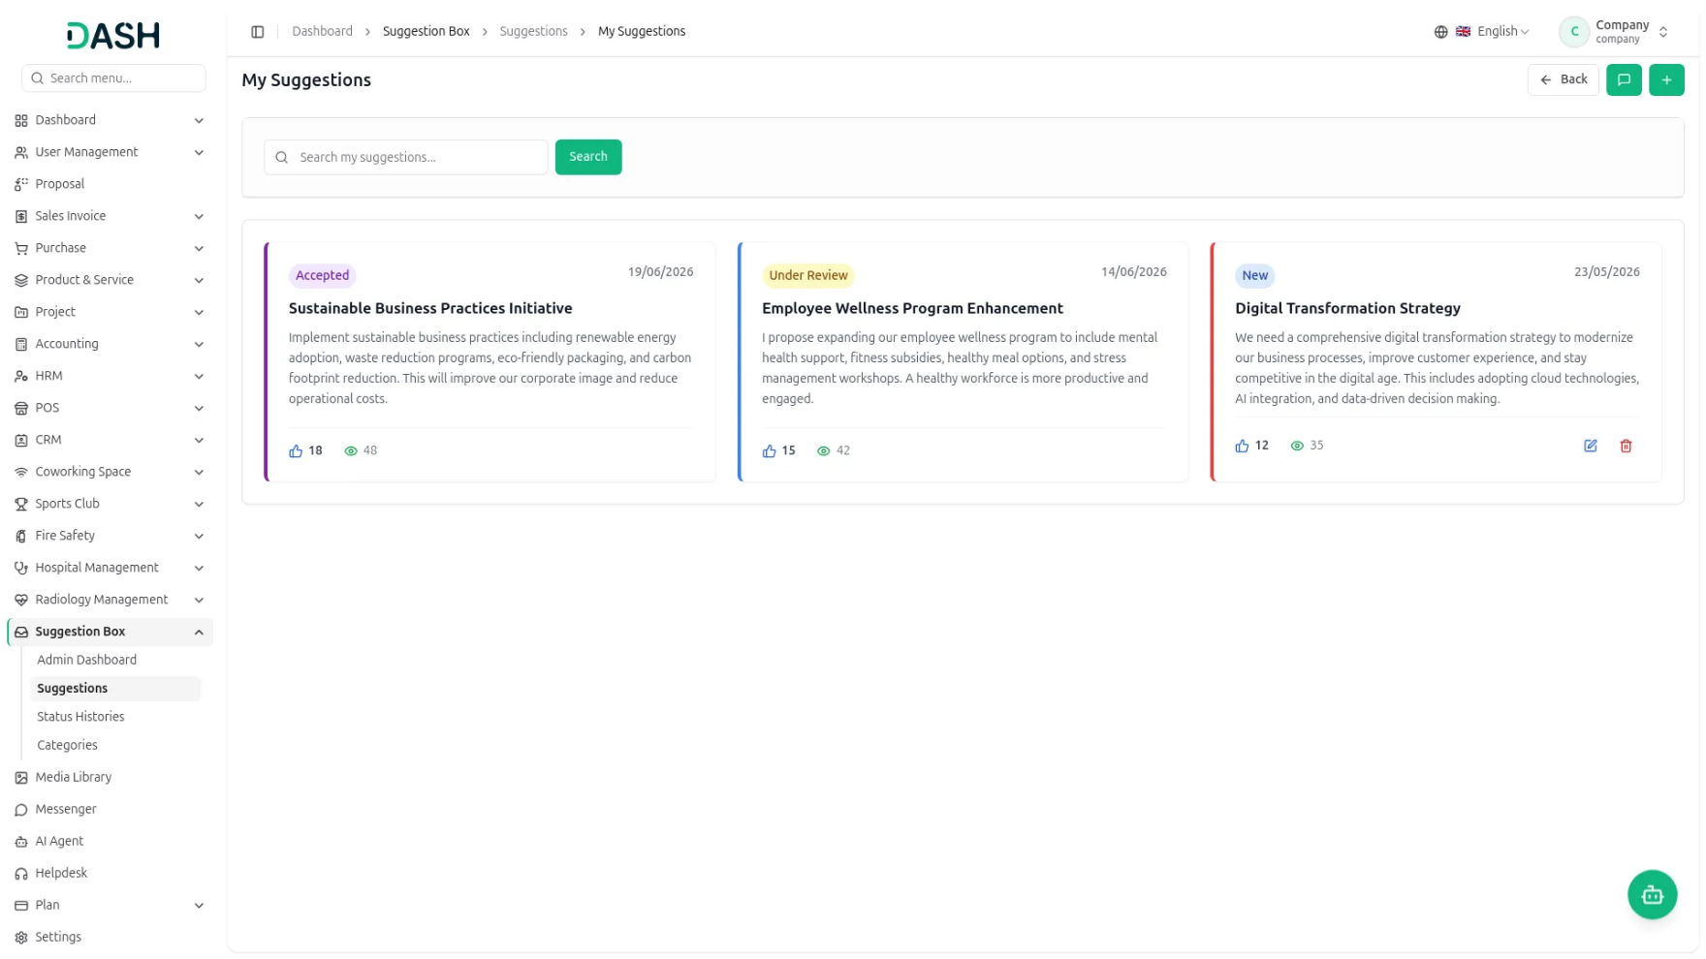
The Suggestion Box Add-On is a digital platform where employees can submit ideas to improve the company and help drive innovation. Employees can also track their submissions and vote on suggestions from others. Admin reviews all ideas, provides feedback, and accepts or rejects them while keeping everyone updated on progress and outcomes.

Key Features Of :Designed for Better Suggestions:
- Category Selection
- Anonymous Submissions
- Voting System
- View Tracking
- Admin Response Panel
- Status Workflow
- Status History Log
- Category Management

STRONG BRAND
Submit and Support Ideas
The Suggestion Box Add-On gives every employee a simple place to share ideas and back the ones they like. A suggestion is created with a title, a category, and a description and can be submitted anonymously when a name should stay hidden. Each suggestion appears as a card showing its status, date, vote count, and view count, so progress stays visible to everyone.
- Create a suggestion with title, category, and description fields.
- The option to submit ideas anonymously has been enabled.
- Vote on colleagues’ suggestions (no self-vote) allowed.
- Manage, edit, delete new submissions; view stats.

Admin Review and Response
Administrators manage everything from a dedicated dashboard built for quick decisions. Summary cards show the count of suggestions in each stage, and a single table lists every submission with its key details. Admins can search, filter, and export the data, then respond directly to any suggestion to share a decision or feedback.
- View status cards summarizing all suggestions.
- Table view with search, filter, and export options.
- Update status and respond to suggestions directly.
- Automatic history log on status changes.

Track Status and Categories
The Add-On keeps a clear record of how each idea moves forward and how suggestions are organized. Every status change is logged, so the full journey of an idea can be reviewed at any time. Categories can be created and styled to keep submissions sorted and easy to scan across the platform.
- Track suggestions through defined workflow stages.
- View full status change history logs.
- Create categories with name, color, and order.
- Category colors are displayed on the suggestion cards visually.

Introduction
The Suggestion Box Add-On is a centralized platform that enables employees to share ideas, engage with suggestions through voting, and track their progress in a transparent workflow. Administrators can review, respond to, and manage all submissions through a dedicated dashboard, ensuring every idea is properly evaluated. The system improves communication between employees and management by organizing suggestions, tracking engagement, and providing visibility into feedback and responses throughout the process.
In short, the flow works like this:
Employee has an idea → Submits a suggestion → Admin reviews → Decision made → Employee gets an update

How To Use The Suggestion Box Add-On?
Admin Dashboard
- The Admin Dashboard gives the Admin a quick summary of all suggestions through status cards: Total Suggestions, New, Accepted, Under Review, Complete, and Rejected.
- The table below lists every suggestion with columns for Title, Submitted By, Votes, Views, Date, Category, Status, and Actions. Use the Search suggestions bar to find specific records and apply Filter Dropdowns (status, category, date range) to narrow results. Then click ‘Apply’ to activate filters or ‘Clear’ to reset them. Use Export to export the data to Excel, PDF, or CSV.
- In the Actions column, use the response button to reply to a suggestion and the view button to open its full details.
- When you click the response button in the Actions column, to open the Admin Response window. Choose the new Status from the dropdown (New, Under Review, Accepted, Rejected, or Complete). Write your Response to explain the decision or provide feedback. Then click Update to save.
Suggestions
- To add a new Suggestion, click the “Create” button to open the Create Suggestion form and enter a Title, choose a category from the dropdown (comes from the manage category section), and write a Description of your idea. Tick Submit anonymously if you want to hide your name from the suggestion. Click Create to submit.
- The Suggestions page shows every suggestion as a card. Each card displays the status badge, the submission date, the title, the description, the submitter’s name (or Anonymous), the vote count, and the view count.
- Use the Search bar to find specific suggestions and apply Filter Dropdowns (category, status) to narrow results. Then click ‘Apply’ to activate filters or ‘Clear’ to reset them.
- Employees can vote to like or support other employees’ suggestions. You cannot vote on your own ideas.
- Note : Employees can only edit or delete their own New suggestions. You cannot vote on your own ideas. Anonymous suggestions hide your name. All suggestions get reviewed by management. You get notified of status changes.

My Suggestions
- When you click the “My Suggestion” button, you can see the My Suggestions page, which shows the suggestions you have submitted, each with its current status, date, title, description, vote count, and view count.
- Suggestions with the New status display Edit and Delete option, so you can edit or delete your own new suggestions. Use the ‘Search my suggestions’ bar to find a specific entry, or click Back to return to the previous page.

Viewing a Suggestion
- When you click a specific suggestion to view its details, the “View Suggestion” page displays the complete information for that individual suggestion. Basic Information lists Submitted By, Category, and Status. Engagement Stats show the Vote Count and Views Count.
- Voted By lists everyone who voted for the suggestion, and Viewed By lists everyone who viewed it. The description shows the full text of the idea. Submission Details show the Submission Date and Submission Type. Response Details (right panel) show the ‘Responded By’ and the ‘Response Date’.
- If the admin responds, the Admin Response section displays the administrator’s reply to the submitted suggestion.

Status Histories
- The Manage Status Histories page records every status change made to a suggestion. Each row shows the Suggestion, who it was Changed By, the Old Status, the New Status, and Actions.
- Each suggestion goes through these stages: New (submitted), Under Review (being checked), Accepted (approved), Rejected (not approved), and Complete (done/implemented).
- Use the Search Status Histories bar and Filters to find specific entries, and use the Actions to view the suggestion status history or delete a record.

Manage Categories
- To add a new category, click the Create button and fill in these fields, including entering the category Name, choosing a Color for the category, and entering the order in which the category appears. Use Toggle this on to make the category ‘Is Active’. Click Create to save the category.
- The Manage Categories page lists the categories that suggestions can be organized into. Each row shows the Name, Color, Display Order, Description, Status, and Actions.
- The category color shown here should also appear on the category cards in the “My Suggestions” grid section.
- Use the Search Categories bar to find a category and apply the Filter Dropdowns status (active/inactive) to narrow results. Then click ‘Apply’ to activate filters or ‘Clear’ to reset them.
- In the Actions column, use the Edit button to change a category’s details or the Delete button to remove it.

Employee Side Login
Once an employee logs in, they can access the Suggestion Box directly from their dashboard. The module provides a simple and transparent way to submit ideas, track their progress, and engage with suggestions submitted by colleagues.
The employee can browse all submitted suggestions that are visible to employees. Users can view suggestion details, support valuable ideas through voting, and stay informed about ongoing improvement initiatives within the organization.
Track the current status of each suggestion (such as New, Under Review, Accepted, Rejected, or Implemented). View responses or feedback provided by administrators and reviewers. Monitor the progress of suggestions from submission through final decision. This ensures employees have complete visibility into their submitted ideas and can easily follow the review process without needing to contact administrators directly.

There are 4 Sub-menu
1. Admin Dashboard
2. Suggestions
3. Status Histories
4. Categories

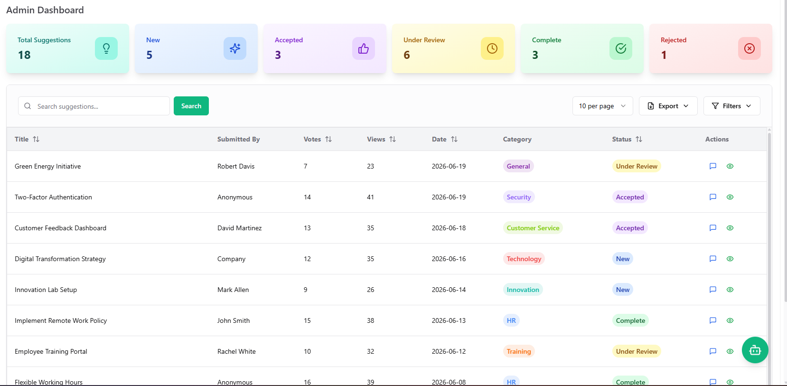
  - Admin Dashboard

3.Status Histories
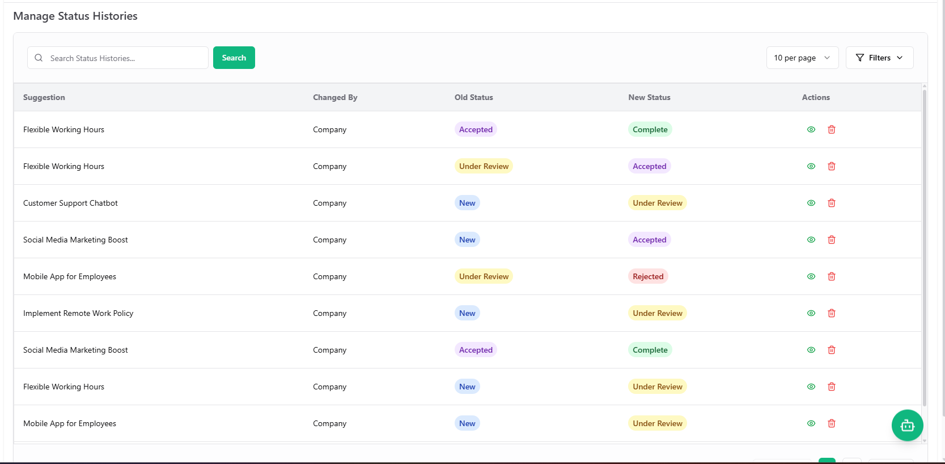
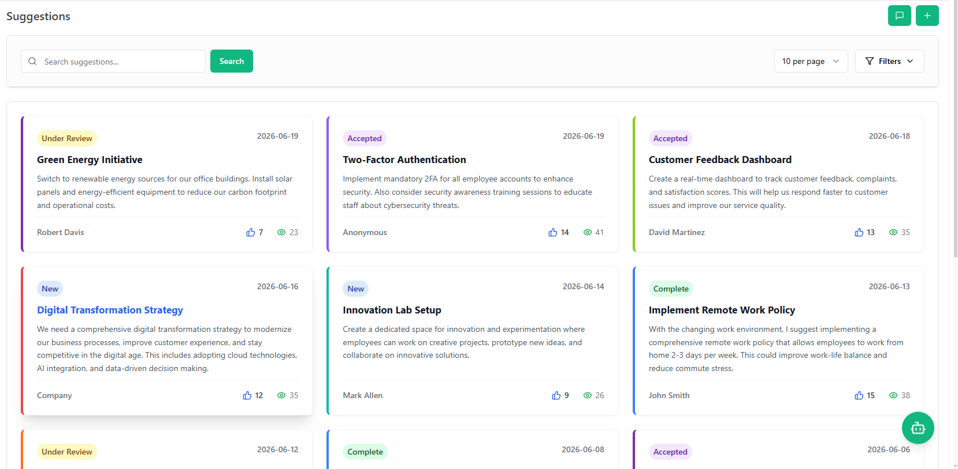
  - Suggestions
  - Categories
